ANNOUNCING: PRAGUE SUMMER 2015

www.praguesummer.org

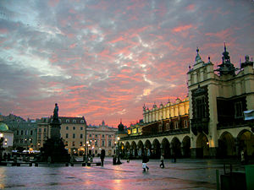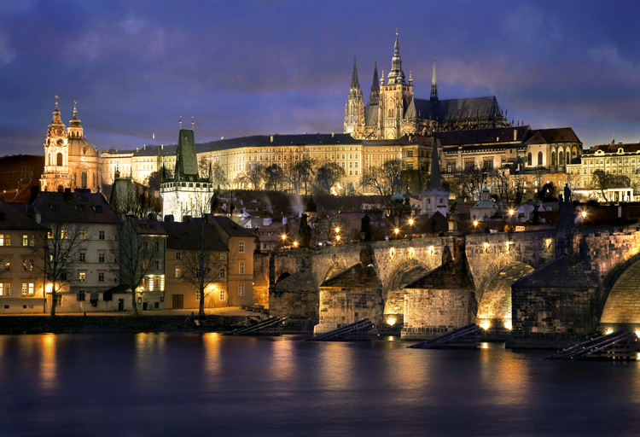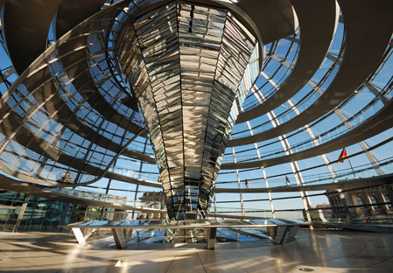

Informational Meeting for Parents and Students
at Newton North and Newton South High Schools
^{on} Tuesday, October 21st, 2014
at 6:30pm in the Film Lecture Hall - NNHS

Newton Summer School
in
The Czech Republic (Prague)
Poland (Krakow)
Germany (Dresden and Berlin)

29 June - 15 July 2015 |  | INCLUSIVE COST: $4,295.00

* 2.5 credit course of study on site  * Cultural enrichment:  *Architecture  *Music  *Theater  *Central European Studies  *Day trips to: Lidice, Cesky Krumlov  Auschwitz, Salt Mines,  Berlin Sites | Tour Package includes:  *Air transportation  *All ground transportation  *Room & board (breakfast  & lunch or dinner)  *Cultural events  *Admission fees  *Local guides  *Curriculum materials

COURSE OF STUDY

This course is for graduation and/or department credit in the Newton Public Schools. Students will be expected to 1) read articles and historical accounts both before they begin the trip and during their stay in Prague, Krakow, and Berlin, 2) keep a writer’s notebook of their experiences, and 3) write several short papers. Prior to departure, there will be an evening orientation session for students and parents and a full day orientation, students only.

The program, entering our 27th year, will be spent on site in Krakow (Poland), Prague (The Czech Republic), Dresden and Berlin (The Federal Republic of Germany). A typical day will include a morning class on history, architecture, contemporary politics, or literature; an afternoon divided between small group work and exploration of the cities; and some evenings will include opportunities for cultural activities, one of which is required.

SPECIFIC ASPECTS OF THE PROGRAM

KRAKOW: The focus will be on the castle area, the medieval Jagiellonian University, the old Jewish Quarter (the site for the film “Schindler’s List”), the unique architecture of the city center (the largest market square in Europe), the unusual town planning of Krakow (the medieval walls were torn down and replaced by a green belt of grass and trees, thus creating a vehicular-free city), and the 600 year old Wieliczka Salt Mines. There will be a day trip to Auschwitz / Birkenau, the most notorious death camp of the Holocaust.

PRAGUE: The course begins with a systematic introduction to the five sections of the central city: Hradcany, Mala Strana, Josefov (the Old Jewish Quarter), Stare Mesto, and Nove Mesto. There will be day trips to Lidice (the small mining town that was razed by the Nazis in 1942 in retaliation for the assassination of Reichsprotektor Reinhard Heydrich) and Cesky Krumlov (UNESCO site), a restored 13th century medieval town located in the Bohemian Hills close to the Austrian border.

DRESDEN: The “Florence, Italy” of Germany and known in the 20th Century as the city that was fire bombed by the Allies in 1945 (at the end of World War II when it was ascertained that Germany had virtually been defeated). Site visits to the newly opened Military Museum (designed by the world famous architect Daniel Libeskind) and the VW automobile factory (Glasernen Manufaktur) which manufactures the famous “Phaeton”.

BERLIN: The Berlin experience will include a tour of the major sites of this huge, sprawling city (e.g., the Brandenburg Gate, the Reichstag, the Berlin Wall, Check Point Charlie Museum, Humboldt University, the Tiergarten, the Pergamon Museum, the Holocaust Memorial, and the Soviet World War II Memorial). Class topics include the European Union, and recent architecture designs since the fall of the Berlin Wall: Norman Foster's Reichstag and Glass Dome; Peter Eisenman's Holocaust Memorial; and Renzo Piano's Daimler Chrysler complex, known as the Sony Center.

PRAGUE SUMMER STAFF

Albert Cho Greg Drake Walter Lyons
Tom Barry Linda Fries Ty Vignone

CONTACT PERSON

TyVignone Office Room 108 Newton North High School
(617) 559-6346
email: Ty_Vignone@newton.k12.ma.us

Cost: $4,295.00
A $300.00 deposit is due on or before Friday, November 7, 2014.

Check payable to: Prague Summer
c/o Ty Vignone
Newton North High School
457 Walnut Street
Newtonville, MA. 02460

$ 3,995.00 Balance due on or before Wednesday, April 1, 2015
Parent/Student Required Meeting Monday, April 27, 2015 – 6:30-8:00PM – Film Lecture Hall – NNHS

