Newton South High School
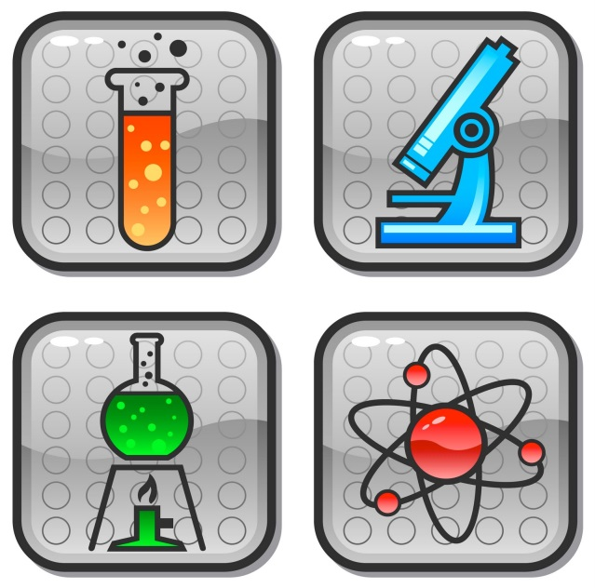
SCIENCE DEPARTMENT
OPEN HOUSE

Thursday May 31
3:30 p.m. - 6:30 p.m.

Please join us in celebrating science, technology, and engineering at Newton South High School
- Open classrooms, with displays of student work, including:
- Family Chemistry Poster projects
- A.P. Biology projects
- Honors & ACP Biology energy projects

- Departmental awards ceremony

- DaVinci STEAM projects, including
- Kinetic sculpture meets Biology final engineering projects
- DNA through art and engineering

- Fun With Chemistry demos for kids by our A.P. Chemistry students
- Student speakers presenting original work
- Technology & Engineering and other displays
- Presentations by the Science Team and the Robotics Team

